Day 3

1. We can set the dummy data value and add another data as we like

* First we imported using the extension



* Then we added the another custom test data

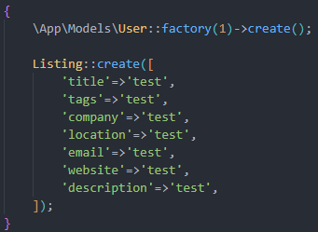

* We then ran the php artisan migrate: refresh –seed command then got the data

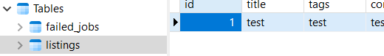

1. Creating a factory for fake data

* First we ran this command



* Now in that php file we added the dummy fake data generator

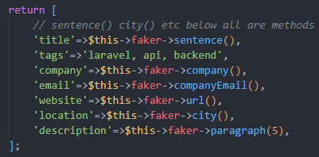

* Now back in the database seeder php file

 this will create 6 dummy data

1. Creating layouts and section as all the frontend that will be repeated such as Navbar footer will be in the layout

* First we create layout dot blade dot php file
* Now in every blade file we need to extend it using



* And every view template needs the section and end section wrapper with a string

 

* And in the layout we need to yield it using the same string to show it



1. Now we have started using the templates

* Here in the template we have added the data using old method



* But the eloquent method allows this syntax



* Image should be put like this



1. Partials

* We use partials folder for some sections and naming convention includes under score

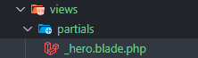

* Now to use it we use include

 if we use extends then it will override

1. Features of eloquent model

* We don’t need to pass id and error handling for showing 404 page with help of

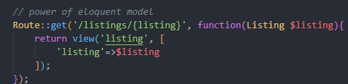

This will auto show error and still works when correct url

1. Props and components

* We make the components folder first



* We pass in props using this syntax



* Now to actually pass the props to the above props we use

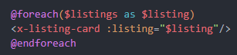 and everything works

* Now again we made a new component

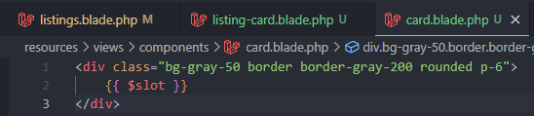

* The slot one is need to wrap. So using it like wrapping inside of this



* In our components we could not use the class if we did this



* So to fix this we did the below syntax



And reusable components ready